SNOWFLAKE PERFORMANCE MANAGEMENT
SCALE UP AND DOWN
We had discussed earlier about dedicated virtual warehouse in creating and giving access to users which improves the performance in snowflake_8 post

Scaling up and down is just to increase or decrease your size of warehouse
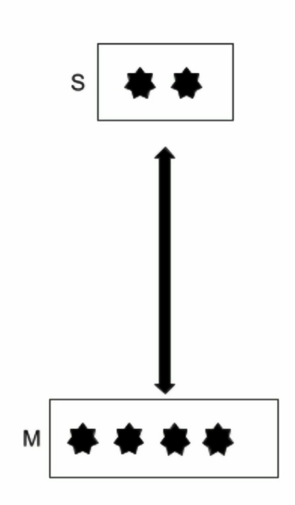
Let’s say you know that at a particular time, your load (complexity of queries) is more
Then you can simply increase your size of warehouse and then once your load is decreased then you can reset to its original size
Hence, by scaling up and down it solves running complex queries faster but not for high concurrency issues or more users (scale out concept to resolve which we will see later)

While creating VWH, take some sizing considerations as follows:
Use auto-suspend, bigger size are costly
Identify similar size/complexity workload and allocate the warehouse (dedicated)

Let’s do it in practical
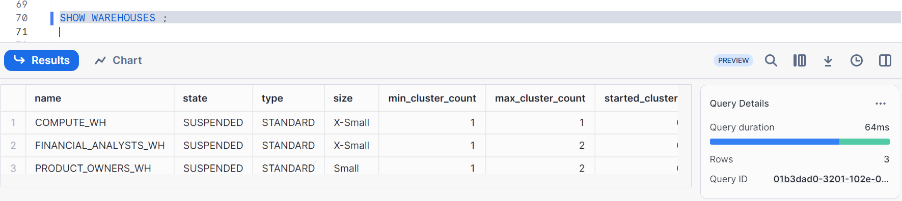
Changing size of product_owners_wh size from small to X-small --- scaling down
Similarly if you want to increase from X-small to small ---- scaling up
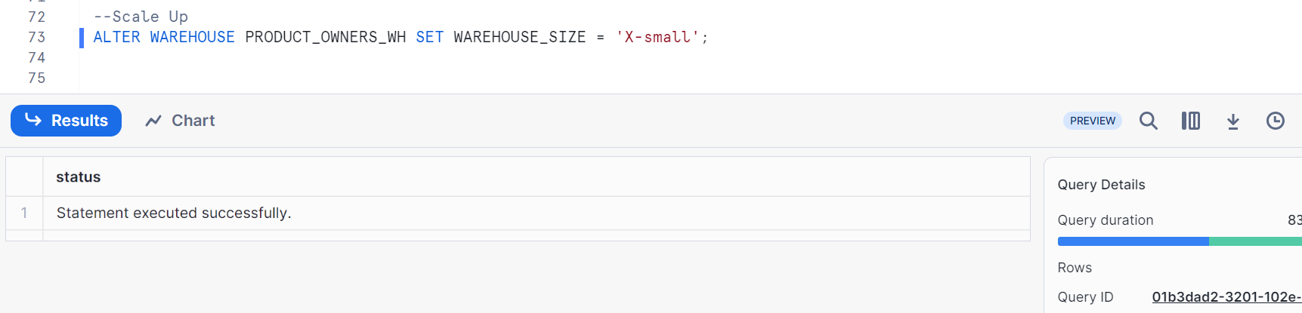
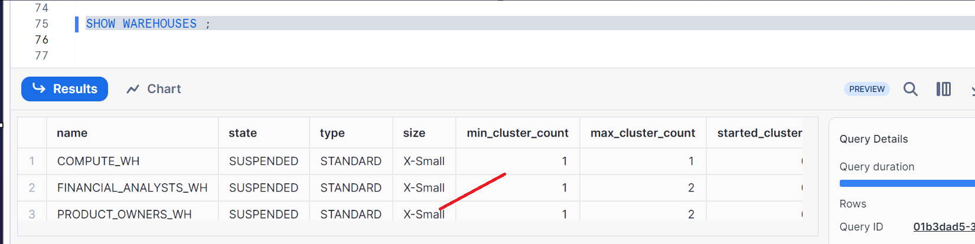

If you want to directly scale up or down from UI, here it is
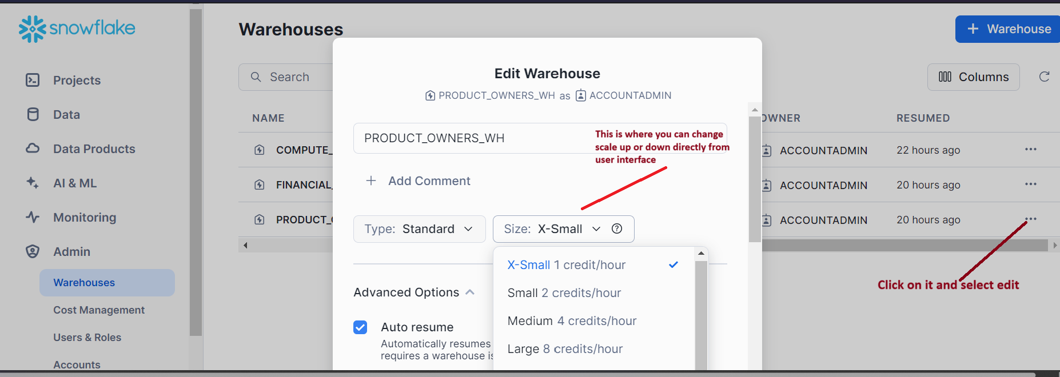
SCALE OUT AND SCALE IN
Scaling out is multi clustering i.e. when there is too much load, snowflake automatically starts additional clusters based on the max clusters you give while creating VWH.
Scaling in is When load goes back down and users are less, then it goes to original i.e. min clusters u gave while creating
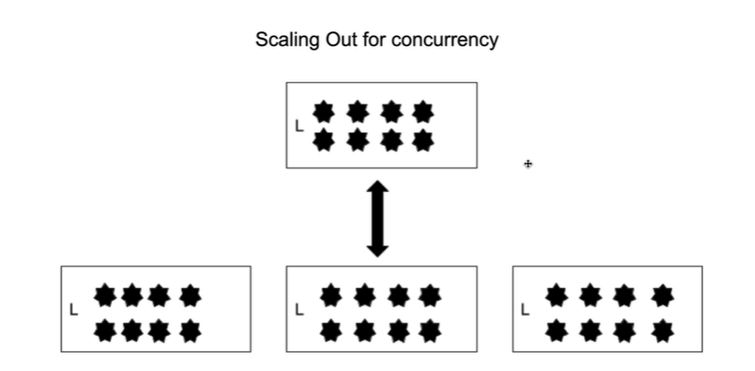
Handles large number of concurrent users
Automatic process of adding and removing clusters based on usage
Queries are load balanced across clusters in virtual warehouses maintained by snowflake
Note:
Multi clustering is available in business enterprise edition and above editions
Min_cluster_count: 1 – 10 (default 1)
Max_cluster_count: 1 – 10 (default) – can be high to solve concurrency issues

Difference between Scaling up and Scaling out
